E-Commerce Sales Analysis Report

## PROJECT OVERVIEW
This project analyzes an E-Commerce Sales dataset to uncover valuable business insights related to sales performance, profitability, customer purchasing behaviour, product performance and regional trends. The project follows a complete analysis workflow including data cleaning, SQL analysis, Python exploratory data analysis (EDA) and an interactive dashboard with KPIs.
---
## OBJECTIVES
- Clean and prepare raw e-commerce sales data.
- Analyse sales and profit performance across different regions and product categories.
- Identify top-performing products and customers data.
- Evaluate payment methods and discount patterns.
- Build an interactive dashboard to support business decision-making.
---
## TOOLS AND TECHNOLOGIES
- Google Sheets – Data Cleaning
- SQL (SQL Server) – Business Analysis
- Python (Pandas and matplotlib) – EDA
- PowerBI- Interactive Dashboard
---

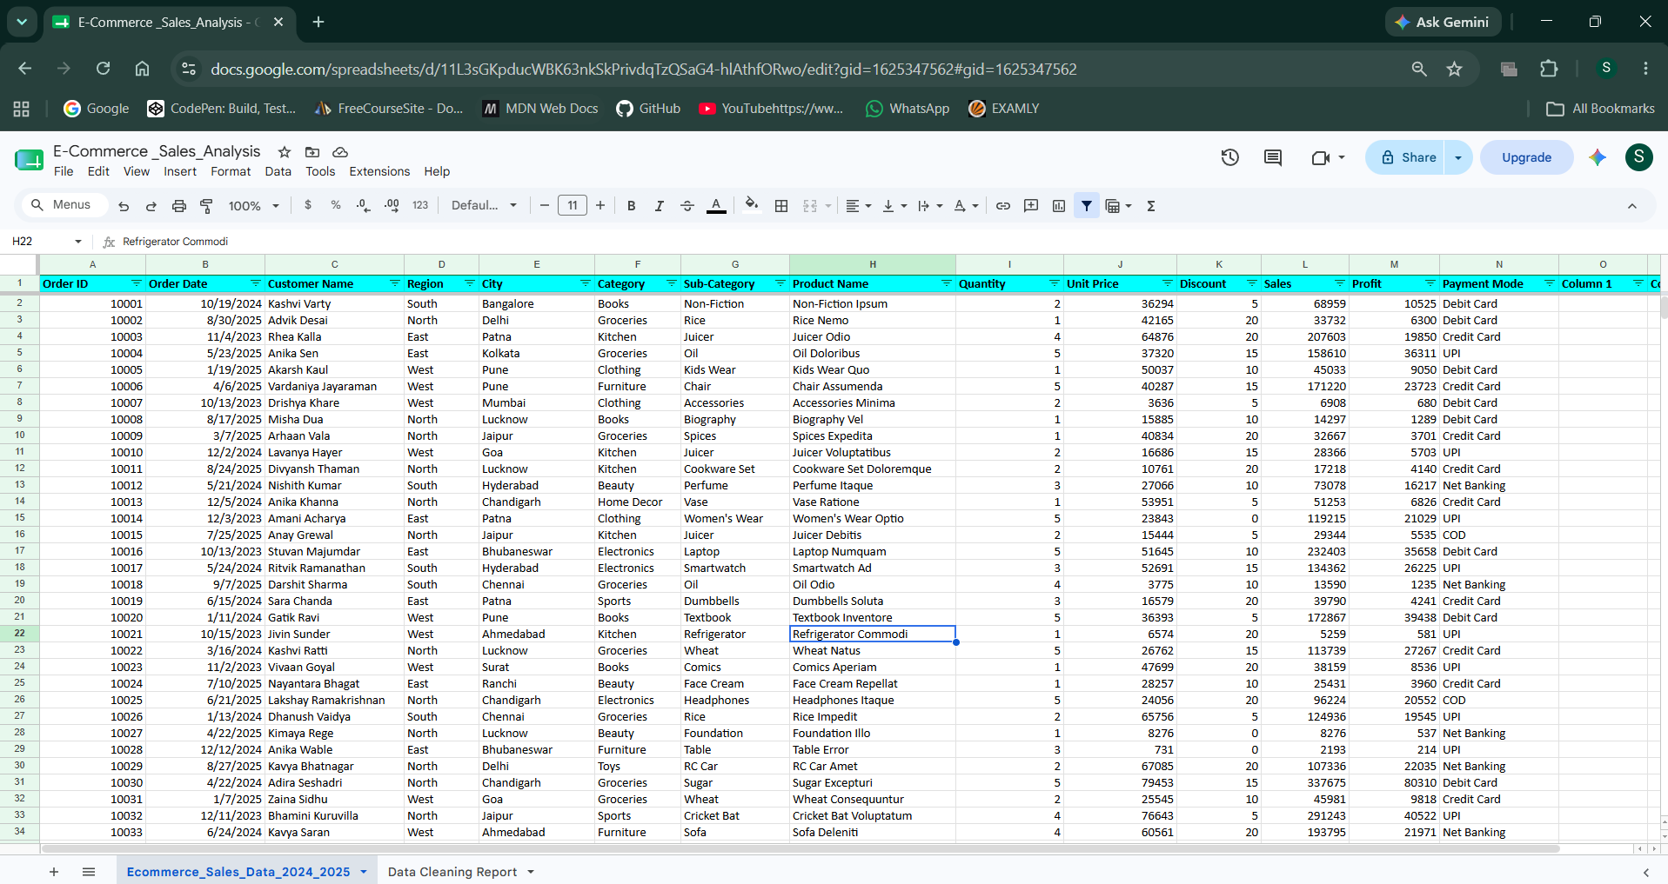
## DATASET INFORMATION

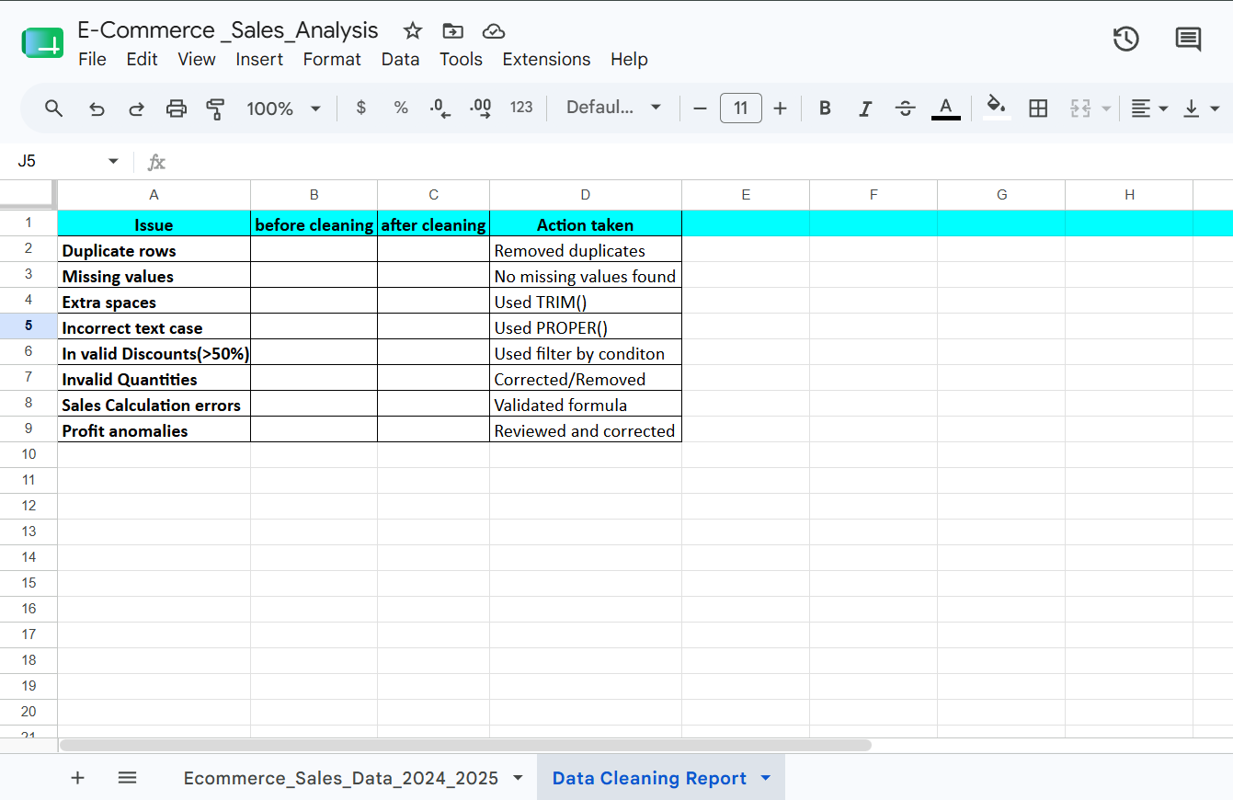
## DATA CLEANING REPORT

---

## DATA CLEANING (GOOGLE SHEETS)
### The following cleaning steps were performed:
- Removed duplicate records
- Checked and handled missing values using conditional formatting
- Corrected invalid discounts (50%)
- Standardized text formatting
- Formatted date and currency columns
- Verified Sales calculations
- Verified Profit values
---
## SQL (BUSINESS ANALYSIS)
### Business questions answered:
- Which region generated the highest revenue?
- Which city has the highest average order value?
- Top 10 products by profit
- Top 5 subcategories by revenue
- Payment method generating the highest revenue
- Products with above average discounts
- Monthly sales trend
- Average profit margin by category
- Products sold above average quantity
- Product ranking by profit
- Running total of monthly sales (Cumulative sales)
- Sales contribution (%) by category
---
### SQL CONCEPTS USED
- GROUP BY()
- ORDER BY()
- TOP
- Aggregate Function
- CASE WHEN()
- Subqueries
- Window Functions – RANK(), OVER()
- Running totals
---
## PYTHON EXPLORATORY DATA ANALYSIS
### Analysis performed:
- Dataset overview
- Missing value analysis
- Sales distribution
- Profit distribution
- Correlation between discount and profit
- Top-selling products
- Average discount by category
- Payment mode distribution
- Profit outlier detection

### Python Libraries
- Pandas
- Matplotlib
---
## POWER BI DASHBOARD
### KPI Cards
- Total Sales
- Total Profit
- Total orders
- Profit Margin %
- Average Discount

### Dashboard Visuals
- Monthly Sales trend
- Sales by Category
- Profit by Sub-category
- Top 10 City by Profit
- Sales by Payment Method
- Sales by Region

### Interactive Filters
- Region
- Month
- Category
---

## Key Insights
- The highest revenue was generated by the top-performing region, highlighting strong regional demand.
- A small group of products contributed a significant share of total profit.
- Digital payment methods accounted for a large portion of sales transactions.
- Certain sub-categories consistently outperformed other in revenue generation.
- Some product categories maintained higher profit margins despite offering discounts.
- Monthly sales showed noticeable fluctuations, indication seasonal buying patterns.
---

## BUSINESS RECOMMENDATION
- Focus marketing efforts on the highest-performing regions.
- Increase inventory for top-selling products to avoid stock shortages.
- Review discount patterns for low-profit products.
- Develop loyalty programs targeting high-value customers.
- Promote high-margin product categories through targeted campaigns.
- Encourage the use of preferred payment methods to improve customer convenience.
- Monitor monthly sales trends for better inventory planning.
---

## CONCLUSION
### This project helped to find out the ecommerce company that globally operates what problems were facing and how to solve those issues by taking actionable ways to support business decision making. These issues are common in many ecommerce companies. Simple and actionable strategies can contribute to perform effectively.
---
Author: Sneha Sharma

